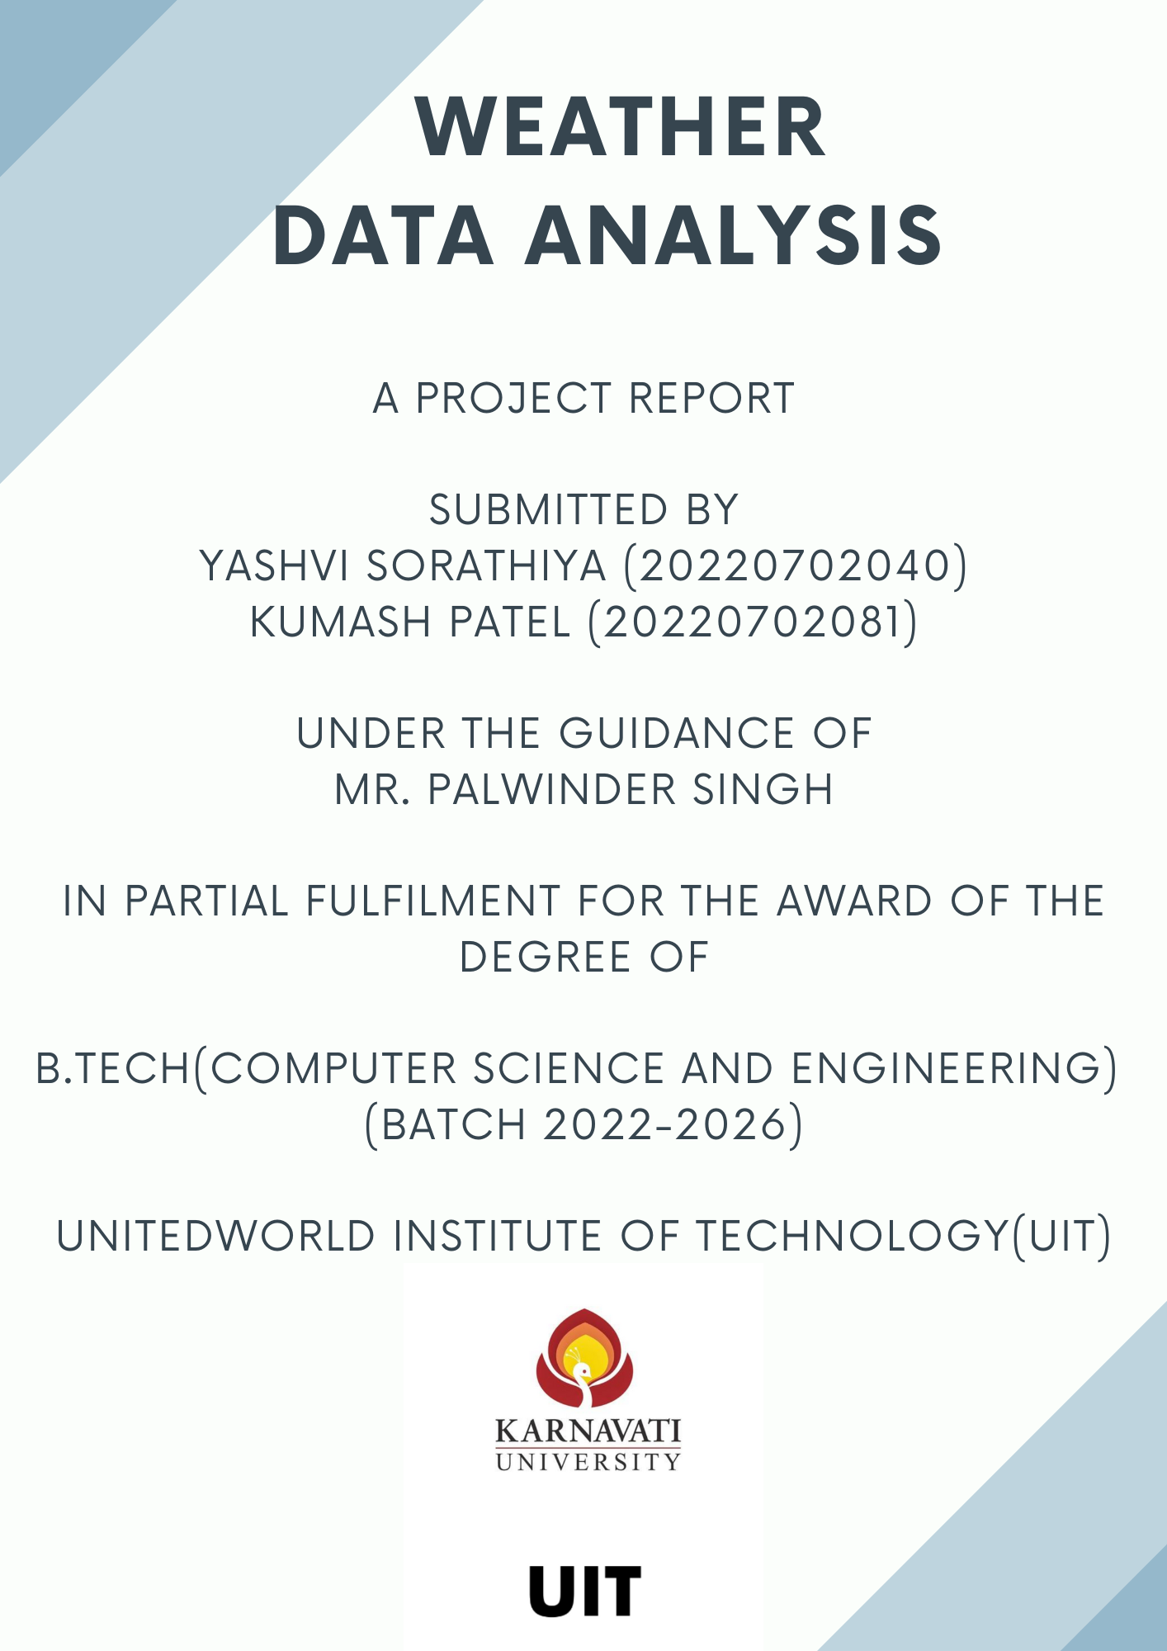

INDEX

Topic Pg.no

Abstract 3

Introduction 4

Problem Statement 5

My Solution 6

System Overview 8

Result and Conclusion 10

ABSTRACT

Weather data analysis plays a crucial role in understanding and interpreting the complex patterns and trends of our atmospheric conditions. In this project, we employ the powerful tools of Python, specifically leveraging the Pandas and Seaborn modules, to delve into the intricate dynamics of weather data. Our objective is to explore, visualize, and analyse various meteorological parameters, including temperature, humidity, precipitation, and wind patterns, over a specified period. By employing descriptive statistics, data visualization techniques, and advanced analytical methods, we aim to uncover insights into the behaviour of these weather variables and their interrelationships.

Through this project, we not only showcase the efficacy of Python for data analysis tasks but also contribute valuable insights into understanding the intricate nature of weather phenomena, which have significant implications for various sectors, including agriculture, transportation, and urban planning.

INTRODUCTION

Understanding and analysing weather patterns is crucial for numerous applications across various sectors, from agriculture and transportation to urban planning and disaster management. In the era of big data, the availability of vast amounts of weather data provides an unprecedented opportunity to gain insights into the dynamics of our atmosphere. In this project, we embark on a journey to harness the power of Python programming, utilizing the Pandas and Seaborn modules, to conduct a comprehensive analysis of weather data. Our primary objective is to explore the multifaceted aspects of meteorological parameters such as temperature, humidity, precipitation, and wind speed, leveraging statistical analysis and data visualization techniques. By delving into historical weather data over a specified timeframe, we aim to uncover meaningful patterns, trends, and correlations, which can provide valuable insights for decision-making processes in various domains.

Through this, we not only demonstrate the capabilities of Python for data analysis but also contribute to the broader understanding of weather dynamics, thereby facilitating informed decision-making and enhancing resilience in the face of changing weather patterns and climate variability.

PROBLEM STATEMENT

Weather data analysis presents numerous challenges due to the inherent complexity and variability of atmospheric phenomena. Despite the wealth of available data, extracting meaningful insights from raw weather datasets remains a daunting task. The challenge lies in identifying significant patterns, trends, and relationships within the data that can provide actionable insights for various stakeholders. In this project, our primary aim is to address this challenge by leveraging the capabilities of Python, specifically the Pandas and Seaborn modules, to conduct a systematic analysis of weather data. We seek to overcome the obstacles of data complexity, volume, and heterogeneity to uncover hidden patterns and correlations that can inform decision-making processes in fields such as agriculture, transportation, and disaster preparedness. By formulating and implementing appropriate analytical approaches, our goal is to extract actionable insights from weather data that can mitigate risks, optimize resource allocation, and enhance resilience in the face of changing weather patterns and climatic conditions.

KEY CHALLENGES:
- Managing the large volume and diversity of weather datasets.
- Ensuring data quality and consistency through rigorous pre-processing.
- Navigating the complexity of weather patterns and interactions between variables.
- Communicating findings effectively to stakeholders with varying technical backgrounds.

MY SOLUTION

To address the challenges posed by weather data analysis, we have employed a systematic approach leveraging the capabilities of Python, particularly utilizing the Pandas and Seaborn modules. Our solution begins with meticulous data pre-processing techniques to handle the vast volume and diversity of weather datasets effectively. We have implemented robust data cleaning and validation procedures to ensure the quality and consistency of our data, thereby mitigating the risks associated with inaccuracies and inconsistencies. In navigating the complexity of weather patterns, we have utilized advanced analytical techniques and visualization methods provided by Pandas and Seaborn. By harnessing descriptive statistics, correlation analysis, and sophisticated visualization tools, we have gained valuable insights into the intricate dynamics of meteorological variables, identifying significant patterns and relationships. Additionally, we have focused on developing clear and intuitive data visualizations and summaries to effectively communicate our findings to stakeholders with varying levels of technical expertise. Through these comprehensive solutions, we have aimed to provide actionable insights that can inform decision-making processes across a range of applications, contributing to the advancement of weather data analysis methodologies and empowering stakeholders to make informed decisions in the face of changing weather conditions.

Objectives to the Problem Statement:
- Explore and analyse weather data using Python's Pandas and Seaborn modules.
- Pre-process weather datasets to handle volume, diversity, and ensure data quality and consistency.
- Identify significant patterns, trends, and relationships within meteorological variables.
- Utilize descriptive statistics and advanced analytical techniques to gain insights into weather dynamics.
- Develop clear and informative data visualizations to communicate findings effectively.
- Provide actionable insights to stakeholders in various sectors, including agriculture, transportation, and disaster management.
- Contribute to the advancement of weather data analysis methodologies and decision-making processes.

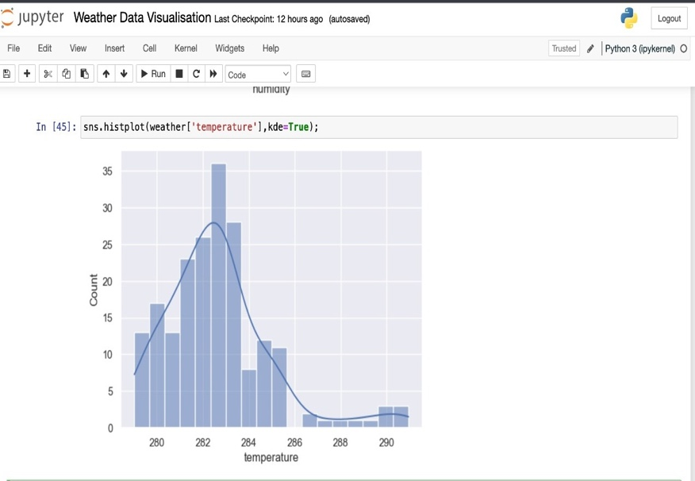
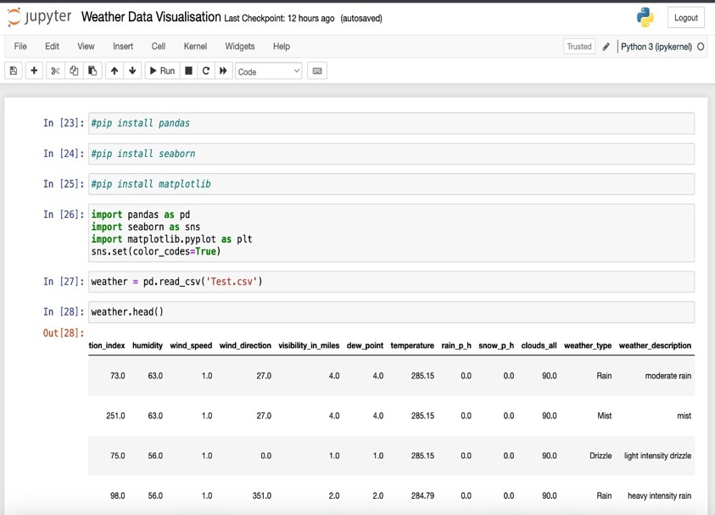

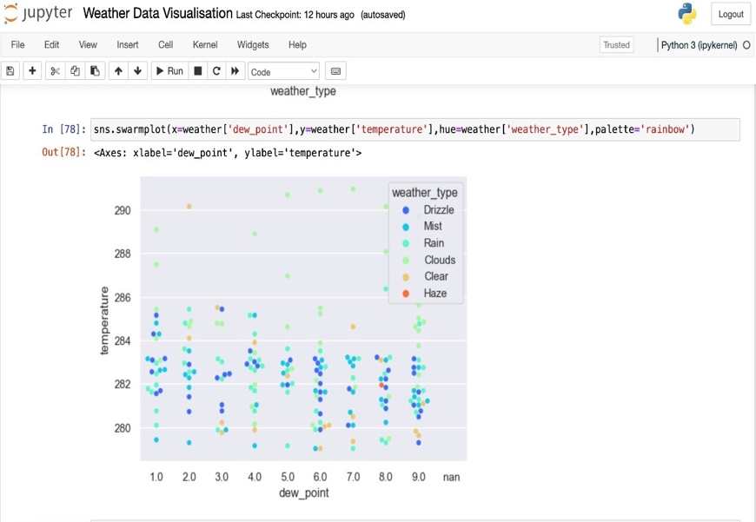
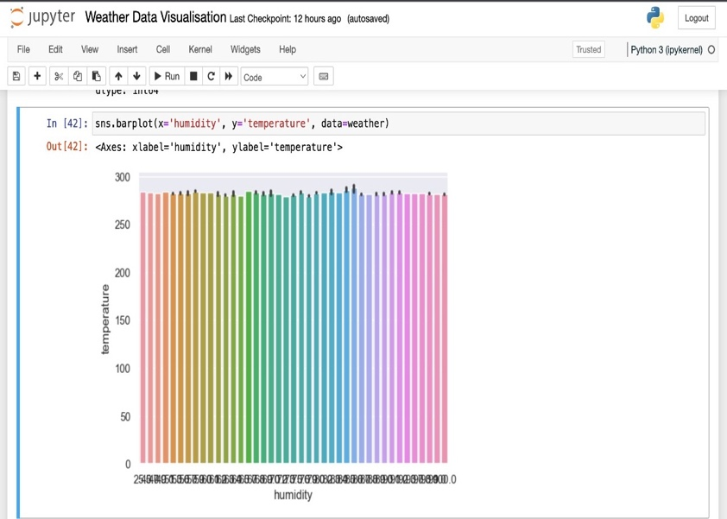

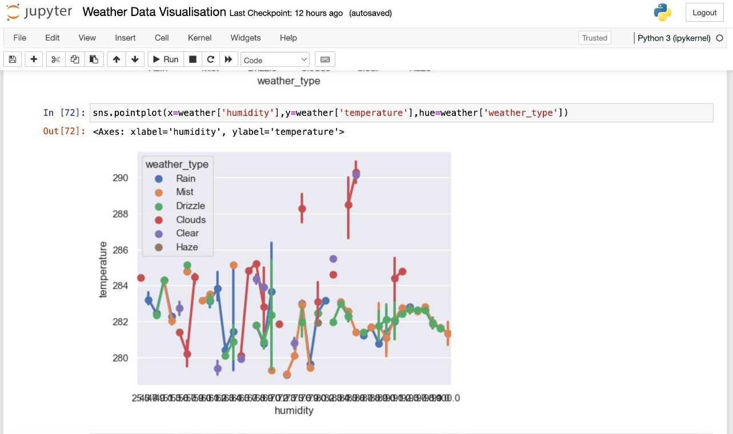

SYSTEM OVERVIEW

Pandas and Seaborn are two indispensable Python libraries that greatly enhance the capabilities of data analysis and visualization.

Pandas: Pandas is a powerful library for data manipulation and analysis. It provides data structures like DataFrame and Series that simplify working with structured data. Pandas excels at tasks like data cleaning, transformation, aggregation, and exploratory data analysis. Its versatility and ease of use make it an essential tool for handling the diverse and voluminous weather datasets encountered in this project.

Seaborn: Seaborn is a statistical data visualization library that builds on top of Matplotlib. It offers a high-level interface for creating visually appealing and informative statistical graphics. Seaborn provides a wide range of plotting functions and themes designed specifically for exploring complex relationships and patterns in data. With Seaborn, we can create insightful visualizations that help uncover hidden insights within weather data, making it an invaluable asset in our analysis toolkit.

Together, Pandas and Seaborn empower us to efficiently analyze and visualize weather data, facilitating the extraction of meaningful insights and patterns that contribute to a deeper understanding of meteorological phenomena. Throughout this project report, we showcase the effective utilization of these libraries to tackle the challenges of weather data analysis and derive actionable insights.

RESULT & CONCLUSION

In conclusion, this project has demonstrated the power and effectiveness of utilizing Python libraries such as Pandas and Seaborn for weather data analysis. Through a systematic approach encompassing data pre-processing, exploratory data analysis, and visualization, we have gained valuable insights into the dynamics of meteorological variables. Our analysis has uncovered significant patterns, trends, and relationships within weather data, shedding light on various aspects of atmospheric phenomena.

Looking ahead, there is immense potential for further exploration and refinement of weather data analysis methodologies. Future endeavours could focus on integrating machine learning techniques to develop predictive models for weather forecasting or incorporating real-time data streams for dynamic analysis. Overall, this project serves as a testament to the power of Python and its libraries in unlocking valuable insights from weather data, paving the way for continued advancements in the field of meteorology and beyond.

